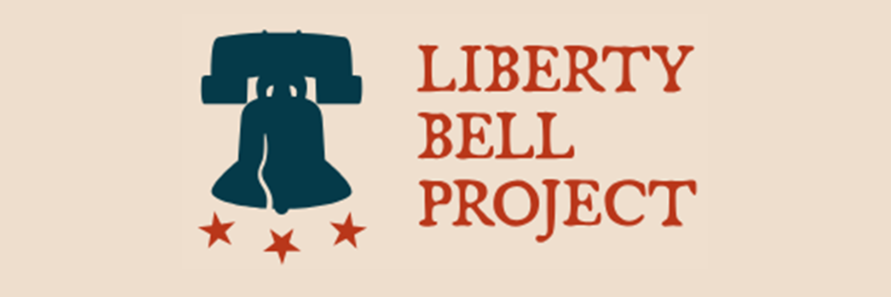

Job Title: Founding Citizens Institute intern
Location: Royston, GA
Organization: Liberty Bell Project – Founding Citizens Institute
Type: Internship
Compensation: Paid stipend
Start Date: Flexible
Duration: 200 hours

About Liberty Bell Project and Founding Citizens Institute
Liberty Bell Project is a 501(c)(3) non-profit education and training initiative that promotes the principles of a citizen-led free society. LBP is expressly nonpartisan and we do not conduct policy advocacy. LBP aims to strengthen the “critical infrastructure” of America’s free society: robust competitive markets, responsive democratic government, resilient and vibrant communities, dedicated and active citizens, public safety, and legitimacy of legal processes.

LBP’s Founding Citizens Institute trains young Americans to become active citizens who take ownership of their communities and the future of our country, with an ethos of agency and accountability based on the principle that every U.S. citizen is both a founder of our country and the most basic critical infrastructure of our free society. Headquartered at the former Royston Elementary School, FCI trains 10-to-18 year old students through after-school programming and an intensive summer camp to become active and engaged citizens who take ownership of their communities and the future of our country. The first formal Founding Citizens Institute Summer Camp will take place in summer 2026, coinciding with celebrations honoring the 250th anniversary of the Declaration of Independence. In addition to FCI activities, the revitalized Royston Elementary School campus is being redeveloped as a hub for education, training, youth leadership, community services and recreation, job training and economic development. The facility will also house Shining Stars Pediatric Therapy, Connections for Special Parents, activities of Emmanuel University, and other vital programs for local families.

Position Overview
Liberty Bell Project seeks a motivated and detail-oriented intern to support Founding Citizens Institute’s citizens training curriculum development and programming implementation for the inaugural class of Founding Citizens, as well as planning and management of redevelopment of the Royston Elementary School campus to support a wide variety of related education, training, and community purposes.

Key Responsibilities
- Work directly with the CEO of LBP to develop and implement citizens training curriculum through early 2026 and to execute the inaugural Founding Citizens Summer Camp.
- Interface with local leaders to include the Mayor of Royston, Superintendent of Franklin County, other municipal and county leaders, as well as teachers and parents of young Founding Citizens and the students themselves.

Qualifications
- Current SPIA student.
- Motivated, entrepreneurial “self-starter” with confident presence and strong written and verbal communication skills;
- Familiarity with municipal and county governance;
- Detail-oriented with strong organizational and time management skills.

Ideal Additional Qualifications
- Prior experience in municipal policy, nonprofit activities, or youth sports and education;
- Graphic/content creation and social media writing experience.

To Apply
Applications will be reviewed on a rolling basis. You can apply by emailing your resume and a statement of interest and qualifications to the CEO of the Liberty Bell Project at clete@libertybellproject.us.

