POLSCI 1101E: Introduction to American Government Syllabus
Fall 2022
Dr. Audrey A. Haynes (she/hers)
706-542-2933 (office)
polaah@uga.edu (email)

VIRTUAL OFFICE HOURS: 11 am to 12 pm on W and by appointment; I will be available to you via our course eLC message pager if I am on eLC, Zoom, email and by phone (just email me if you wish to talk) during office hours. I will also be available for in-person meetings by appointment. The BEST way to reach me quickly is through my email: polaah@uga.edu. I generally will respond within a few hours but no later than 24 hours. If you do not hear from me, email me again. Why? There is likely a problem with the email. If you receive an email from the eLC class list (to all) you should not reply back to it. You must start a new email either to my direct email address or within eLC.

COURSE DESCRIPTION: This course is concerned with government and politics in the United States, primarily at the national level, but attention will be given to state and local government, particularly the nature of Georgia’s Constitution. We will examine the institutional rules and human behaviors that shape government, the operation of elections, the development of parties and interest groups, public opinion, and the functioning of Congress, the presidency, and the courts. An historic overview of the topics will shed light on how the current system has evolved. This is important since the foundation of our system and the rules and norms established early have a great impact on how the government performs what policies it produces and how its citizens relate to it.

We may also focus our attention on current political, social and economic events and draw attention to how they relate to the governmental concepts we are studying. In addition, we will also cover a variety of theories of, and perspectives on, government. At times, I will post news articles or bits of information on the Announcement board or the Discussion board, and your thoughts are welcome and expected. In fact, email any time you have a question or thought you wish to discuss.

Specific topics and the time at which they will be covered, as well as your assigned reading can be found on the calendar on this course’s eLC portal, in your checklist, and in the announcements. If you ever are in any doubt about a deadline, email your TA or your professor.

PREREQUISITES OF THE COURSE: None

TECHNICAL REQUIREMENTS OF THE COURSE: If you are able to access the Internet on a regular basis, you meet the technical requirements for the course. It is important that you have reliable Internet service, particularly as the tests are time sensitive. You also need a reliable laptop or desktop computer. I would not suggest taking tests or quizzes on your phone. It is not reliable, particularly for the short answers questions. If that is all you have, then let me and your TA know.

COURSE OBJECTIVES: At the start of each of our content modules, you will see a list of course objectives. They range from general understanding of a process to very specific skills (such as being able to determine what type of collective action problem is being described or predicting the outcome of a political situation. Please make sure to read through these objectives. They will correspond to the learning outcomes/assessments. At the end of the semester look back and them and let me know if you feel that you have not achieved competency in those objectives. We will make sure you do.

COURSE TEXTBOOK: Logic of American Politics 8th edition. You may purchase the electronic version or the paper text, whichever text you feel more comfortable working with for your course reading. There is a 9th and 10th edition, BUT do not purchase these. We are keeping costs low this semester and using the 8th edition. You are welcome.

You may purchase the hard copy of the textbook through whatever online bookstore you prefer, order it through UGA’s bookstore, but it must be this book:

The Logic of American Politics (8th edition)
Samuel Kernell, Gary C. Jacobson, Thad Kousser, and Lynn Vavreck
CQ Press
Paperback or e-version
Published: March 21, 2017

ISBN: 1506358667 (print) 1506385184 (ebook)

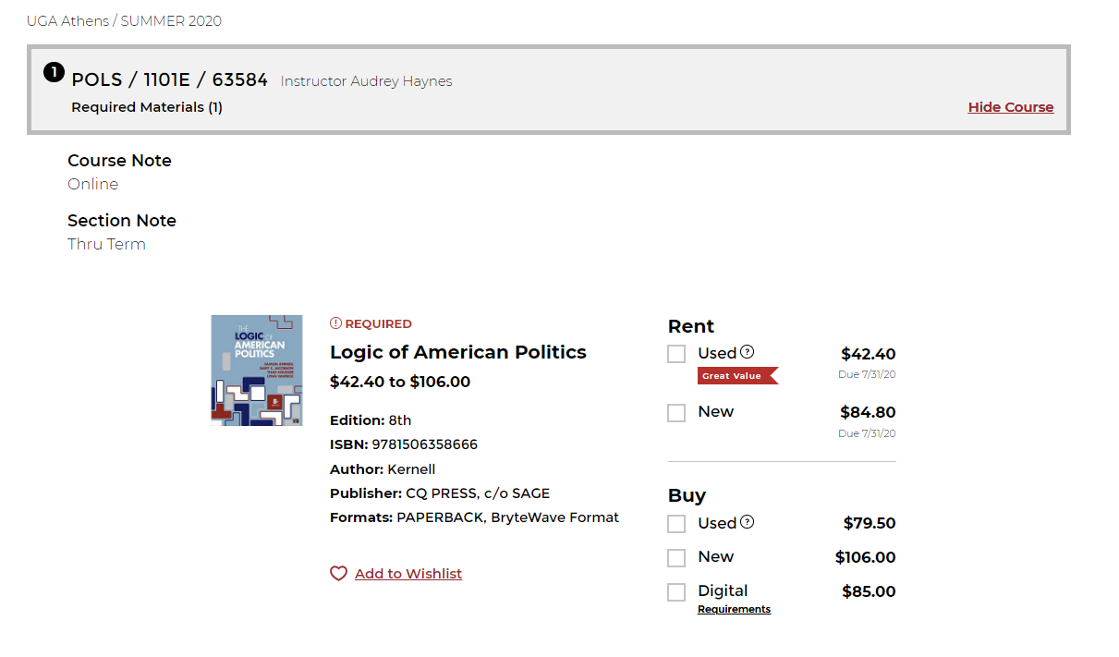

Above is what you will see if you go to the UGA Bookstore. You can rent or purchase the book there. The prices are a bit higher than you might find other places, but for this course I only require one book and if you rent a used copy, you are still under $50. (I am sensitive to cost as I have my own child in college at the moment.) I also have the first chapter or two in pdf form in the start module, so you have use of that while hunting for a better bargain. I encourage you to check out the pdf before you buy.

You may purchase or rent the textbook from other sources as well. But do not trust any site that is not a confirmed business such as Amazon, Barnes and Noble, Chegg.com, Textbooks.com, etc. If you see a higher price, it is likely you are purchasing the 9th edition in some cases. Look for the picture that you see here and make sure it is the 8th edition. Some specific questions on my tests will not be in the 9th edition as there are some changes. Not a tremendous number, but enough.
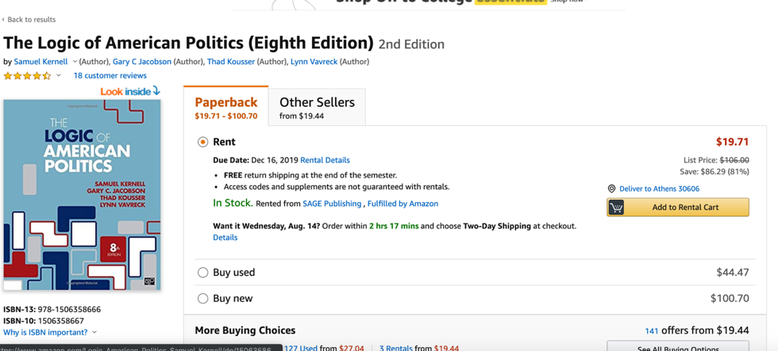

ONLINE LEARNING ENVIRONMENT: This course is hosted on UGA eLC. If you have any issues at any point, make sure to contact:

EITS Help Desk: helpdesk@uga.edu or 706.542.3106.
Business hours are 8am - 10pm (Mon-Thurs), 8am-6pm (Fri), and 1pm-7pm (Sat-Sun)

Go the University System of Georgia Desire2Learn Online Help Center at
http://D2Lhelp.view.usg.edu. From this site, you can search the Knowledge Base, browse popular articles, or click the link for live support (24x7x365) in the scrolling news area.

GRADING AND ASSIGNMENTS:
Your grade for this course will be determined by your scores on your tests, quizzes and discussion essays, your final project. Each assessment counts toward a percentage of your grade. To see the distribution of weight for each assessment, simply go to the Grades link on the course page and review the list of assessments and their individual and group weights.
Grades:

Concept, video, other quizzes 20%
Discussion assignments 20%
Exams 35%
Course final project 25%

Total: 100%

Grade scale:

A 93.0000 and above
A- 92.9999 to 90.0000
B+ 87.0000 to 89.9999
B 86.9999 to 83.0000
B- 82.9999 to 80.0000
C+ 77.0000 to 79.9999
C 76.9999 to 70.0000
D 65.0000 to 69.9999
F 64.9999 and below

There is no rounding/curving at the end of the semester. Note this now so that you are properly motivated to achieve your grade goal. It is open book and open note. Some of the test questions may be challenging, but that is required when we have an open book and open note course. There is also ample opportunity for you to earn extra credit.k

Learning Activities: In this course your learning activities consist of the following: reading your text, viewing/listening to course lectures, playing games, discussing relevant topics on the discussion board with your professor, TAs and your peers, completing your tests and discussion essays, working on your final project, and viewing relevant videos. Almost all activities are graded. NOTE: This is an online, asynchronous class. The goal is to expose you to critical concepts and historical developments as well as the theories that underly governance and politics. If you have expectations of significant interaction with real human beings, this is not the course that will achieve it. It is a course with real learning goals, but there are constraints with a course that has over 300 students and is virtual. We have tried to design it to meet a wide variety of needs and goals, and I hope you know that if you do want that interaction, all you have to do is email or zoom with me or TA. You have to put that effort in if that is one of your goals.

Course outline and schedule: The course is outlined extensively on its eLC course site. The schedule is located on the calendar. If you have any questions at all about the schedule, please contact Dr. Haynes immediately.

Start Module
Follow due dates for individual assignments in Start Module Checklist

Part I
- Module 1: Why Government?
- Module 2: Constitutional Foundations
- Module 3: Federalism
- Module 3.1 Civil Rights (video lecture and quiz only; no reading)

Deadline for all Part I Module work is September 9 by 11:59 pm. Part I modules close on September 12. Late work will have a 10-point penalty.

Part II
- Module 4: Legislative Branch
- Module 5: Executive Branch
- Module 6: Judicial Branch
- Module 6.1: Civil Liberties (video lecture and quiz only; no readings)
Deadline for all Part II Module work is October 7 by 11:59 pm; Part II modules close on October 10. Late work will have a 10-point penalty.

Part III
- Module 7: Voting
- Module 8: Political Parties
- Module 9: Interest Groups

Deadline for all Part III Module work is November 7 by 11:59 pm; Part III modules close on November 10. Late work will have a 10-point penalty.

Part IV
- Module 10 The Mass Media
- Module 11: Public Policy
- Module 12: The Georgia Constitution and Government
- Final paper project

Deadline for all Part IV Module work is December 8 by 11:59 pm; Part IV modules close on December 11. Late work will have a 10-point penalty. No Late papers accepted.

Policies: This course follows all policies related to Academic Honesty and Student Code of Conduct as outlined by the University of Georgia.
http://www.conduct.uga.edu/code_of_conduct/codeofconduct.pdf
http://ovpi.uga.edu/academic-honesty/academic-honesty-policy

Student Agreement: By enrolling in this course, you agree to adhere to these policies linked above and to do your best to be a good, productive, and honest student. You also agree to work with Dr. Haynes to make sure that you have a positive learning experience and a rewarding course outcome and that you will not neglect to stay on top of your work. Nor will you interact with your peers to collaborate on any exams, essays or projects unless they are clearly designated as group projects or work.

Religious Holidays: Just make sure to inform your TA and Professor Haynes when you require accommodation for a religious holiday. We are glad to accommodate.

NOTE: Professional courtesy and sensitivity are especially important with respect to individuals and topics dealing with differences of race, culture, religion, politics, sexual orientation, gender, gender variance, and nationalities. Class rosters are provided to the instructor with the student’s legal name. I am eager to address you by your preferred name and/or gender pronoun. Please advise your TA and Professor Haynes of this preference early in the semester so that I may make appropriate changes to my records.

