POLSCI 1101E: Introduction to American Government Syllabus
Fall 2020
Dr. Audrey A. Haynes
706-542-2933 (office)
polaah@uga.edu (email)

Virtual Office Hours: 11 am to 12 pm on W and by appointment; I will be available to you via our course online chat room, eLC message pager if I am on eLC, Zoom, and Skype via appointment, and by phone during work hours. The BEST way to reach me quickly is through my email: polaah@uga.edu. I generally will respond within a few hours but no later than 24 hours. If you do not hear from me, email me again. Why? There is likely a problem with the email. If you receive an email from the eLC class list (to all) you cannot reply back to it. You must start a new email either to my direct email address or within eLC.

Course Description: This course is concerned with government and politics in the United States, primarily at the national level, but attention will be given to state and local government, particularly the nature of Georgia’s Constitution. We will examine the institutional rules and human behaviors that shape government, the operation of elections, the development of parties and interest groups, public opinion, and the functioning of Congress, the presidency, and the courts. An historic overview of the topics will shed light on how the current system has evolved. This is important since the foundation of our system and the rules and norms established early have a great impact on how the government performs what policies it produces and how its citizens relate to it.

We will also focus our attention on current political, social and economic events and discuss how they relate to the governmental concepts we will be studying. During this time we will also discuss a variety of theories of, and perspectives on government. At times, I will post news articles or bits of information on the Announcement board or the Discussion board, and your thoughts are welcome and expected.

Specific topics and the time at which they will be covered, as well as your assigned reading can be found on the calendar on this course’s eLC portal.

Prerequisites of the Course: None

Technical requirements of the course: If you are able to access the Internet on a regular basis, you meet the technical requirements for the course. It is important that you have reliable Internet service, particularly as the tests are time sensitive. You also need a reliable laptop or desktop computer. I would not suggest taking tests or quizzes on your phone. It is not reliable, particularly for the short answers questions. If that is all you have, then let me and your TA know.

Course objectives: At the start of each of our content modules, you will see a list of course objectives. They range from general understanding of a process to very specific skills (such as being able to determine what type of collective action problem is being described or predicting the outcome of a political situation. Please make sure to read through these objectives. They will correspond to the learning outcomes/assessments. At the end of the semester look back and them and let me know if you feel that you have not achieved competency in those objectives. We will make sure you do.

Course textbook: Logic of American Politics 8th edition. You may purchase the electronic version or the paper text, whichever text you feel more comfortable working with for your course reading. There is a 9th edition, BUT do not purchase it. We are keeping costs low this semester and using the 8th edition. You are welcome.

You may purchase the hard copy of the textbook through whatever online bookstore you prefer, order it through UGA’s bookstore, but it must be this book:

The Logic of American Politics (8th edition)
Samuel Kernell, Gary C. Jacobson, Thad Kousser, and Lynn Vavreck
CQ Press
Paperback or e-version
Published: March 21, 2017

ISBN: 1506358667 (print) 1506385184 (ebook)

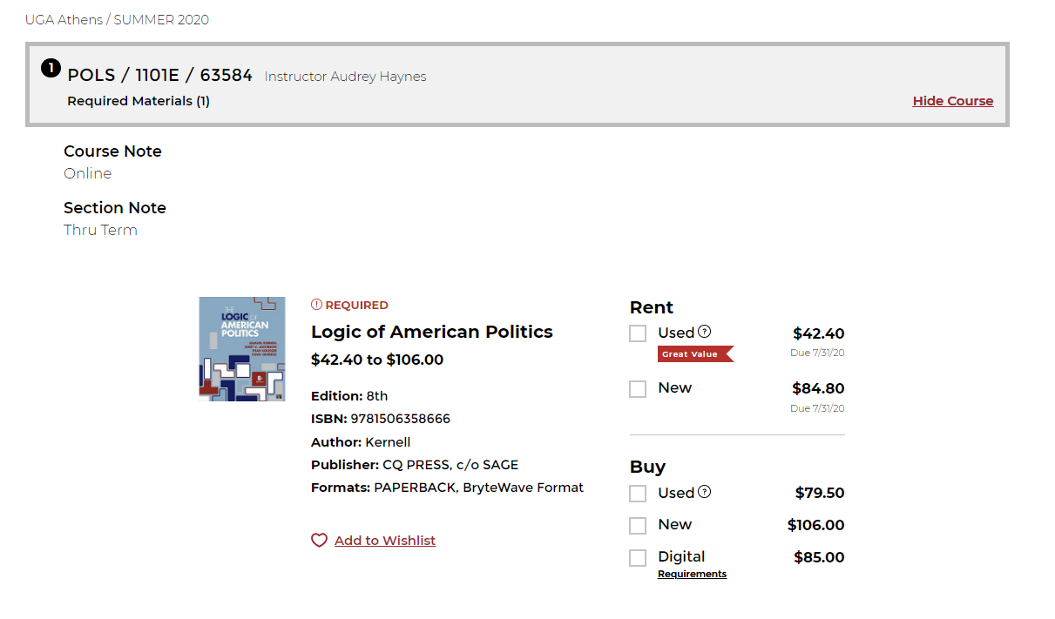

Above is what you will see if you go to the UGA Bookstore. You can rent or purchase the book there. The prices are a bit higher than you might find other places, but for this course I only require one book and if you rent a used copy, you are still under $50. (I am sensitive to cost as I have my own child in college at the moment.)

You may purchase or rent the textbook from other sources as well. But do not trust any site that is not a confirmed business such as Amazon, Barnes and Noble, Chegg.com, Textbooks.com, etc. If you see a higher price, it is likely you are purchasing the 9th edition in some cases. Look for the picture that you see here and make sure it is the 8th edition. Some specific questions on my tests will not be in the 9th edition as there are some changes. Not a tremendous number, but enough.
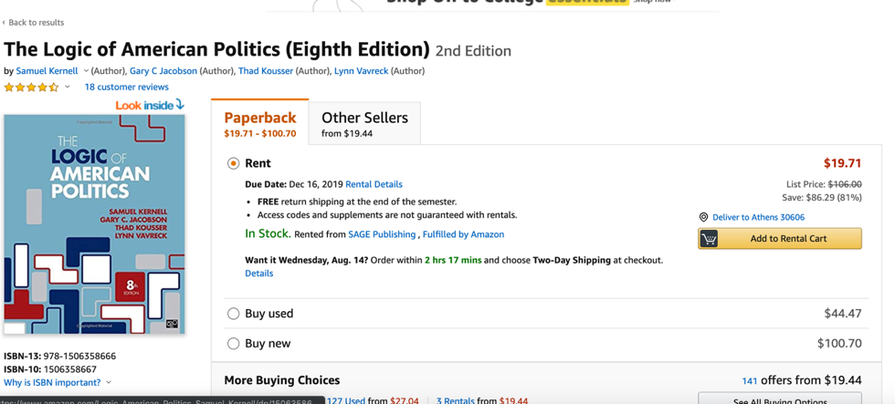

And if you use your Google skills, you may find better bargains. I can guarantee that the UGA Bookstore and Amazon will deliver the product, but other sources may be more or less dependable. I do not know. So order early. You may also find a full pdf on line if you look very carefully. If any website seems sketchy, stay away from it. But some are scams- particularly some pdf downloads. I do have pdfs for chapters 1 and 2, so you are covered if getting your book takes a bit more time.

Online Learning Environment: This course is hosted on UGA eLC. If you have any issues at any point, make sure to contact:

EITS Help Desk: helpdesk@uga.edu or 706.542.3106.
Business hours are 8am - 10pm (Mon-Thurs), 8am-6pm (Fri), and 1pm-7pm (Sat-Sun)

Go the University System of Georgia Desire2Learn Online Help Center at
http://D2Lhelp.view.usg.edu. From this site, you can search the Knowledge Base, browse popular articles, or click the link for live support (24x7x365) in the scrolling news area.

Grading and Assignments:
Your grade for this course will be determined by your scores on your practice tests, tests, quizzes and essays, your final project, and your participation via the discussion board. Each counts toward a percentage of your grade. To see the distribution of weight for each assessment, simply go to the Grades link on the course page and review the list of assessments and their individual and group weights.

Note that you will basically have a concept or video quiz, practice quiz and test every week during the course of the semester. We will work in tandem. There will also be weeks where you have a discussion exercise. There is a final project as well, rather than a final exam. The tests are open book, but they are timed. You must do your reading and studying ahead of time.

Grades:

Practice quizzes 15%
Concept, video, other quizzes 25%
Discussion assignments 15%
Exams 30%
Course project 15%

Total: 100%

Grade scale:

A 93.0000 and above
A- 92.9999 to 90.0000
B+ 87.0000 to 89.9999
B 86.9999 to 83.0000
B- 82.9999 to 80.0000
C+ 77.0000 to 79.9999
C 76.9999 to 70.0000
D 65.0000 to 69.9999
F 64.9999 and below

THERE IS NO ROUNDING OR CURVING AT THE END OF THE SEMESTER. Note this now so that you are properly motivated to achieve your grade goal. It is open book and open note. Some of the test questions may be challenging, but that is required when we have an open book and open note course.

Learning Activities: In this course your learning activities consist of the following: reading your text, viewing/listening to course lectures, playing games, taking practice quizzes, discussing relevant topics on the discussion board with your professor, TAs and your peers, completing your tests and discussion essays, working on your final project, and viewing relevant videos. Almost all activities are graded.

Course outline and schedule: The course is outlined extensively on its eLC course site. The schedule is located on the calendar. If you have any questions at all about the schedule, please contact Dr. Haynes immediately. (See an example of a module below: always has a checklist, formative material, study tools, summative assessments, and extra stuff for you.)

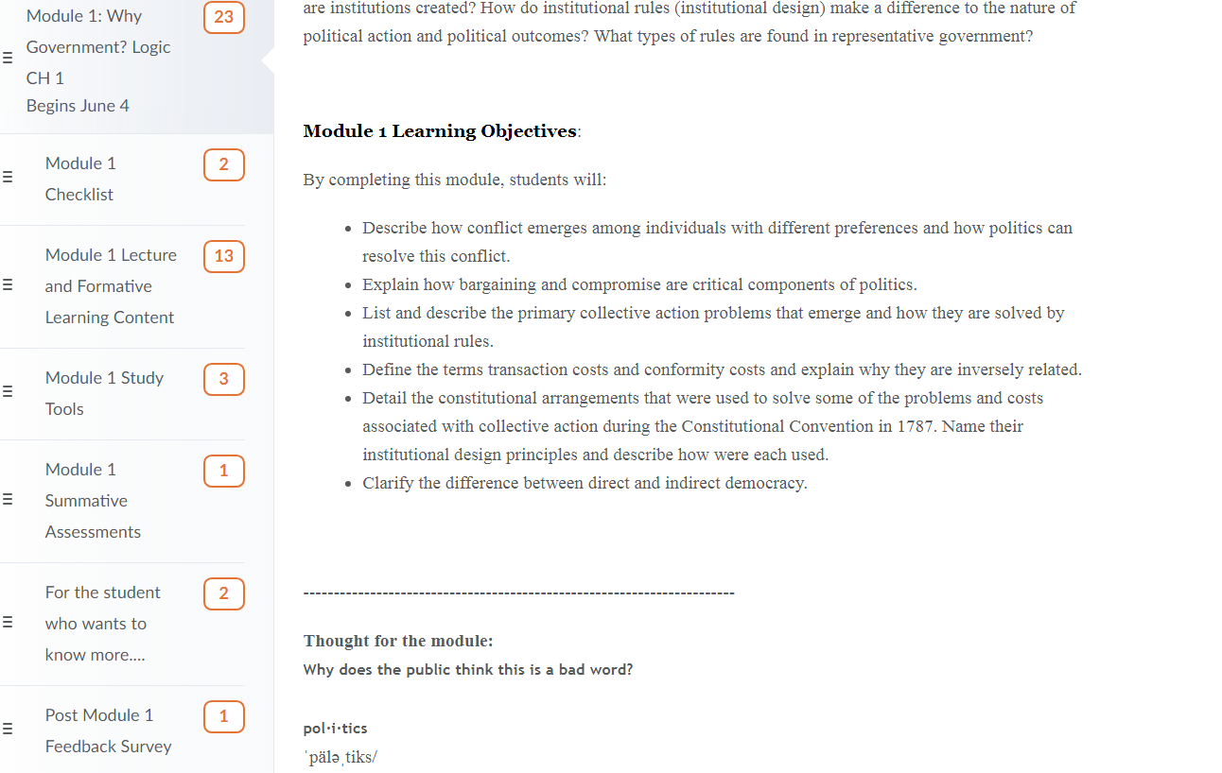

This is an example of what a Module Checklist might look like. Each checklist provides directions and links to the materials and assessments you will be working with.
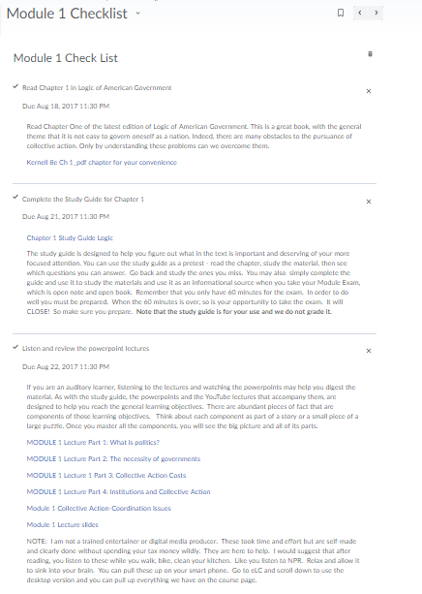
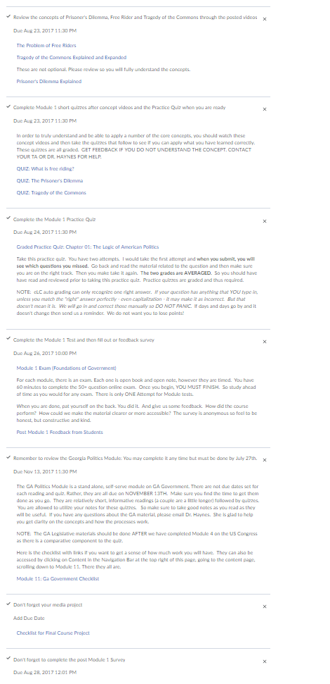
General Schedule
Specific dates are located at the start of each module and in our module checklists. Modules are weekly. So the Start Module is for the first week of class, Module 1 is the next week of class, and the GA Politics module is open throughout the entire course with all work needing to be done in that module by the end of the course.

Start Module
GA Politics Module (open throughout)
Module 1: Why Government?
Module 2: Constitutional Foundations
Module 3: Federalism
Module 4: Legislative Branch
Module 4.1: Civil Rights
Withdrawal date
Module 5: Executive Branch
Module 6: Judicial Branch
Module 6.1: Civil Liberties
Module 7: Voting
Module 8: Political Parties
Module 9: Interest Groups

Final project due on our last day of class prior to final exams. No exceptions. We will be grading 420 papers so we will need that finals time to do so.
We do not have a final exam.

Policies: This course follows all policies related to Academic Honesty and Student Code of Conduct as outlined by the University of Georgia.

http://www.conduct.uga.edu/code_of_conduct/codeofconduct.pdf
http://ovpi.uga.edu/academic-honesty/academic-honesty-policy

Agreement: By enrolling in this course, you agree to adhere to these policies linked above and to do your best to be a good, productive, and honest student. You also agree to work with Dr. Haynes to make sure that you have a positive learning experience and a rewarding course outcome and that you will not neglect to stay on top of your work. Nor will you interact with your peers to collaborate on any exams, essays or projects unless they are clearly designated as group projects or work.

Given this is an online course that moves quickly, if you have any issues regarding test dates (such as a conflict, or you become ill during a portion of the course) it is imperative that you communicate with me (Dr. Haynes) and/or your assigned Teaching Assistant, and work out any issues. Your instructor (me) will try to be flexible given the online nature of this course, which may be new to some of you. So it is very important that you
keep communication lines open. It is very important that you stay on top of your reading and your test deadlines. I have designed this course so that while we move quickly, we are testing only one module at a time. Even though they are open book, given that they are time limited (and they will remain so – only those students with accommodations may seek extended time), you need to be prepared and knowledgeable or you will not be able to complete the test in the time allowed.

Thank you. We appreciate all of our students and are here to provide a supportive yet challenging learning environment.

A full schedule for the course is available on our eLC course page.

Coronavirus Information for Students

Face Coverings:

Effective July 15, 2020, the University of Georgia—along with all University System of Georgia (USG) institutions—requires all faculty, staff, students and visitors to wear an appropriate face covering while inside campus facilities/buildings where six feet social distancing may not always be possible (and to be very safe in non-ventilated classrooms, we will maintain face covering even when we are six feet apart). Face covering use is in addition to and is not a substitute for social distancing. Anyone not using a face covering when required will be asked to wear one or must leave the area. Reasonable accommodations may be made for those who are unable to wear a face covering for documented health reasons. Students seeking an accommodation related to face coverings should contact Disability Services at https://drc.uga.edu/.

DawgCheck:

Please perform a quick symptom check each weekday on DawgCheck—on the UGA app or website—whether you feel sick or not. It will help health providers monitor the health situation on campus: https://dawgcheck.uga.edu/

What do I do if I have symptoms?

Students showing symptoms should self-isolate and schedule an appointment with the University Health Center by calling 706-542-1162 (Monday-Friday, 8 a.m.-5 p.m.). Please DO NOT walk-in. For emergencies and after-hours care, see https://www.uhs.uga.edu/info/emergencies.

What do I do if I am notified that I have been exposed?

Students who learn they have been directly exposed to COVID-19 but are not showing symptoms should self-quarantine for 14 days consistent with Department of Public Health (DPH) and Centers for Disease Control and Prevention (CDC) guidelines. Please correspond with your instructor via email, with a cc: to Student Care & Outreach at sco@uga.edu, to coordinate continuing your coursework while self-quarantined. If you develop symptoms, you should contact the University Health Center to make an appointment to be tested. You should continue to monitor your symptoms daily on DawgCheck.

How do I get a test?

Students who are demonstrating symptoms of COVID-19 should call the University Health Center. UHC is offering testing by appointment for students; appointments may be booked by calling 706-542-1162.

UGA will also be recruiting asymptomatic students to participate in surveillance tests. Students living in residence halls, Greek housing and off-campus apartment complexes are encouraged to participate.

What do I do if I test positive?

Any student with a positive COVID-19 test is required to report the test in DawgCheck and should self-isolate immediately. Students should not attend class in-person until the isolation period is completed. Once you report the positive test through DawgCheck, UGA Student Care and Outreach will follow up with you.

No Dawg Barks Alone. If you need support with mental health in these difficult times, here are some Mental Health and Wellness Resources:
- If you or someone you know needs assistance, you are encouraged to contact Student Care and Outreach in the Division of Student Affairs at 706-542-7774 or visit https://sco.uga.edu. They will help you navigate any difficult circumstances you may be facing by connecting you with the appropriate resources or services.
- UGA has several resources for a student seeking mental health services (https://www.uhs.uga.edu/bewelluga/bewelluga) or crisis support (https://www.uhs.uga.edu/info/emergencies).
- If you need help managing stress anxiety, relationships, etc., please visit BeWellUGA (https://www.uhs.uga.edu/bewelluga/bewelluga) for a list of FREE workshops, classes, mentoring, and health coaching led by licensed clinicians and health educators in the University Health Center.
- Additional resources can be accessed through the UGA App.

