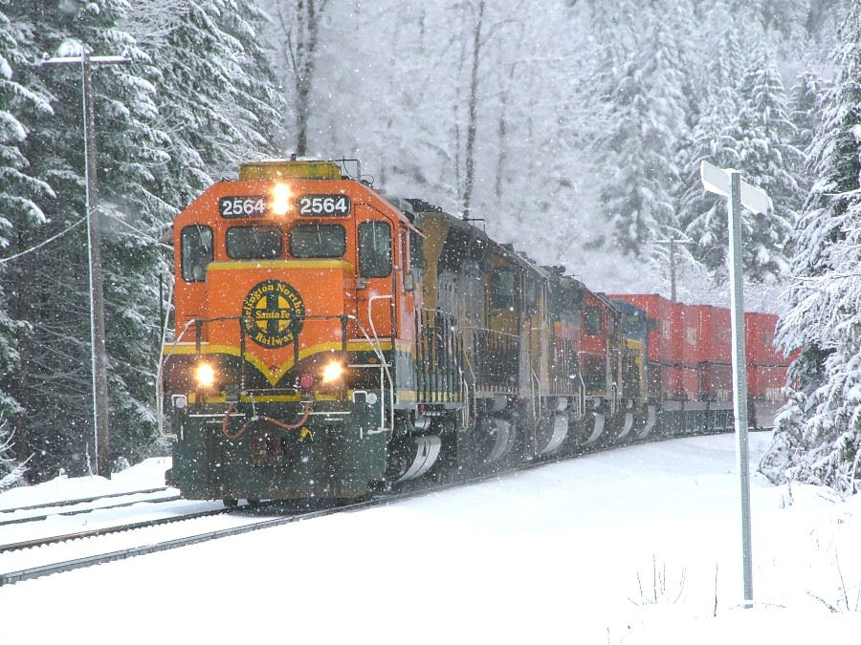
(Photo by Joe O'Connell, 5 February 2005)
POLS 4555: RAILROADS AND AMERICAN POLITICS
Spring Semester AY2019-2020
Department of Political Science
University of Georgia
Athens, GA, 30602-1615
Classroom: Baldwin 301
Time: 2:30 - 3:20PM Monday, Wednesday, Friday
Instructor: Keith T. Poole
Office: Room 304D Baldwin Hall
E-Mail: ktpoole@uga.edu
WebSite: Voteview Home Page
Office Hours: By Appointment
The following texts will be used in this course:
- John F. Stover, American Railroads
- Albro Martin, Enterprise Denied
- John Steele Gordon, The Scarlet Woman of Wall Street
- John Steele Gordon, An Empire of Wealth
- Harold C. Livesay, Andrew Carnegie and the Rise of Big Business
Requirements
Grades will be determined by three examinations -- two mid-semester exams and a final exam. The exams will be multiple choice. The midterms will be worth ¼ each and the final 1/2 of the course grade.
The first Mid-Semester exam will be on Friday, 28 February 2020, one hour, in class.
The second Mid-Semester exam will be on Friday, 3 April 2020, one hour, in class.
The final is scheduled for Wednesday, 6 May 2020 from 3:30 to 5:30PM

Course Outline

- Introduction: Why are Railroads Important?
Assignment:
  - Chapters 1, 2 and 3, An Empire of Wealth
Agenda For Topic 1
<="" a="">Agenda For Topic 1
<="" a="">
Why are Railroads Important? (PowerPoint)
Handout for Topic 1 (Part 1, PowerPoint)
Railroads are the best way to move heavy freight
The Alameda Corridor
The Railroad in American Life

- American Politics, Economics, and Business prior to the Railroads: 1800 - 1830
Assignment:
  - Chapters 4 - 8, An Empire of Wealth
  - Chapters 1 and 2, American Railroads
  - Chapters 1 - 3, A Most Magnificent Machine
Agenda For Topic 2
Handout for Topic 2
St. Louis Museum of Transportation
- Railroads as Big Business
Assignment:
  - Chapters 9 - 12, An Empire of Wealth
  - Chapter 3, American Railroads
  - Chapters 4 - 10, A Most Magnificent Machine
Agenda For Topic 3
Handout For Topic 3 (PowerPoint)
Oil Refining and Coke Production (PowerPoint)
Early Railroad Corporate Charters (PowerPoint)
The Trunk Lines as Big Business (PowerPoint)

- Andrew Carnegie, the Standard Railway of the World, and the Industrialization of the U.S.
Assignment:
  - Chapter 13, An Empire of Wealth
  - Chapters 1 - 11, Andrew Carnegie
  - Chapters 11 - 14 and Conclusion, A Most Magnificent Machine
Agenda For Topic 4
Handout For Topic 4 (PowerPoint)
1937 Newspaper Article about the Lucy Blast Furnace being Torn Down
New Tunnels Being Bored in Manhattan and Queens, New York (PowerPoint)

- The Nature of Railroad Competition
Assignment:
  - Chapter 5, American Railroads
Agenda For Topic 5
The Political Problems of the Railroads (PDF)
Handout For Topic 5 (PowerPoint)
Handout For Topic 5 (PDF)

- Railroads and the Development of Agriculture
Assignment:
  - Chapter 4, American Railroads
  - Chapter 14, An Empire of Wealth
Agenda For Topic 6
The Political Problems of the Railroads (PDF)
Handout For Topic 6 (PowerPoint)
What is Truth?

- Railroads and Government Regulation: 1887-1920
Assignment:
  - Chapters 6 to 8, American Railroads
  - Chapters 15 to 17, An Empire of Wealth
Agenda For Topic 7
Corrupt Practices by Railroad Managers
Handout For Topic 7 (Part 1)
Supreme Court Rulings on State Regulation
The Interstate Commerce Act of 1887
Regulatory Acts 1903-1916
Handout For Topic 7 (Part 2)
Handout For Topic 7 (PowerPoint, Part 1)
Handout For Topic 7 (PowerPoint, Part 2)
Handout For Topic 7 (PowerPoint, Part 3)

- Railroads Triumphant: 1980 - 2012
Assignment:
  - Chapters 9 and 10, American Railroads
  - Chapters 18 to 20, An Empire of Wealth
Agenda For Topic 8
- Railroads and the Future of the American Transportation System
Assignment:
  - Stop This Train! Are Trains Slower Now than they were in the 1920s? Tom Vanderbilt, Slate, May 15, 2009
  - Beware of Low Flying Aircraft! Chris Camp, The Northwest's Own Railfan
  - Improve Existing Rail Lines for Passenger Trains

Site Links
NOMINATE Data, Roll Call Data, and Software
Course Web Pages: University of Georgia (2010 - )
Course Web Pages: UC San Diego (2004 - 2010)
University of San Diego Law School (2005)
Course Web Pages: University of Houston (2000 - 2005)
Course Web Pages: Carnegie-Mellon University (1997 - 2000)
Analyzing Spatial Models of Choice and Judgment with R
Spatial Models of Parliamentary Voting
Recent Working Papers
Analyses of Recent Politics
About This Website
K7MOA Log Books: 1960 - 2014
Bio of Keith T. Poole
Related Links

