POLSCI 1101E: Introduction to American Government Syllabus
Summer Thru Session June 7-July 31, Final Exams: August 1 & 2
Dr. Audrey A. Haynes
706-542-2933 (office)
polaah@uga.edu (email)

Virtual Office Hours: 11 am to 12 pm on W and by appointment; I will be available to you via our course online chat room, eLC message pager if I am on eLC, and Skype via appointment, and by phone during work hours. The BEST way to reach me FAST is through my email: polaah@uga.edu. I generally will respond quickly but no later than 24 hours. If you do not hear from me, email me again. Why? There is likely a problem with the email.

Course Description: This course is concerned with government and politics in the United States, primarily at the national level, but attention will be given to state and local government, particularly the nature of Georgia’s Constitution. We will examine the institutional rules and human behaviors that shape government, the operation of elections, the development of parties and interest groups, public opinion, and the functioning of Congress, the presidency, and the courts. An historic overview of the topics will shed light on how the current system has evolved. This is important since the foundation of our system and the rules and norms established early have a great impact on how the government performs what policies it produces and how its citizens relate to it.

We will also focus our attention on current political, social and economic events and discuss how they relate to the governmental concepts we will be studying. During this time we will also discuss a variety of theories of, and perspectives on government. At times, I will post news articles or bits of information on the discussion board and your thoughts are welcome and expected.

Specific topics and the time at which they will be covered, as well as your assigned reading can be found on the calendar on this course’s eLC portal.

Prerequisites of the Course: None

Technical requirements of the course: If you are able to access the Internet on a regular basis, you meet the technical requirements for the course. It is important that you have reliable Internet service, particularly as the tests are time sensitive. You also need a reliable laptop or desktop computer.

Course objectives: At the start of each of our content modules, you will see a list of course objectives. They range from general understanding of a process to very specific skills (such as being able to determine what type of collective action problem is being described or predicting the outcome of a political situation. Please make sure to read through these objectives. They will correspond to the learning outcomes/assessments.

Course textbook: Logic of American Politics 8th edition. You may purchase the electronic version or the custom paper text, whichever text you feel more comfortable working with for your course reading.

You may purchase the hard copy of the textbook through whatever online bookstore you prefer, but it must be this book:

The Logic of American Politics (8th edition)
Samuel Kernell, Gary C. Jacobson, Thad Kousser, and Lynn Vavreck
CQ Press
Paperback or e-version
Published: March 21, 2017

ISBN: 1506358667 (print) 1506385184 (ebook)

You may also rent the text. One easy way to obtain the ebook is through Vital Source.

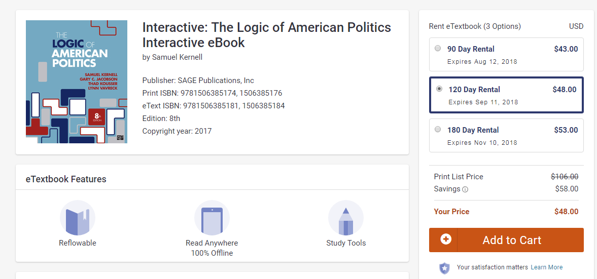

You may even use the least expensive option, the 90 day rental, which is $43. There is no other textbook to purchase. You are welcome. When you rent or purchase an eBook, you generally need to create an account with that source.

Below are the instructions for using VitalSource Bookshelf on a web browser, computer, or mobile device. For quick demos, visit our online Tutorial Videos here (http://downloads.vitalbook.com/tutorials/publish/index.html?did=generic). There is a module for each device, with expanding navigation arrows revealing subtopics. The most popular features are Searching, Highlighting, and making Notes. Should you need further assistance please visit http://support.vitalsource.com

Once you have purchased or rented the book you simply do the following:
To open your book, please follow the appropriate set of instructions given below:
- Getting Started by creating a Bookshelf account, go tohttp://www.vitalsource.com/redeem
To read your book in Bookshelf for Online, please do the following:
- Go to (http://bookshelf.vitalsource.com)
- Sign in with your Bookshelf account email address and password.
- Click on the name of the title to open the book.
To open your book in Bookshelf on your computer, you first must have a Bookshelf account, and then do the following:
- Download Bookshelf for Mac or PC. ( http://www.vitalsource.com/downloads )
- Once Bookshelf is installed, launch Bookshelf.
- Sign in with your Bookshelf account email address and password.
- Click on "All Titles" in the collection pane to view all the books in your account.
- Double click on the title to download the book to your computer. Once downloaded, double-click again to open the book.
To open your book in Bookshelf for iOS and Android, you first must have a Bookshelf account, and then do the following:
- Download Bookshelf for iOS or Android. ( http://www.vitalsource.com/downloads
- Once Bookshelf is installed, launch Bookshelf.
- Sign in with your Bookshelf account email address and password.
- Click on "All Titles" in the collection pane to view all the books in your account.
- Tap on the title to download the book to your mobile device. Once downloaded, double-click again to open the book.

If you have any questions, please let me know. I have downloaded my copy and it is quite easy to use. It basically sits in the cloud waiting for you.

If you would like a hard copy, you can purchase a custom one at a variety of places, online or one of the bookstores in Athens. Simply tell them what you wish to purchase and they will order it for you. I have NOT asked for a certain number to be purchased at any bookstore given most students opt for the eBook due to its “searchable” nature.

Online Learning Environment: This course is hosted on UGA eLC. If you have any issues at any point, make sure to contact:

EITS Help Desk: helpdesk@uga.edu or 706.542.3106.
Business hours are 8am - 10pm (Mon-Thurs), 8am-6pm (Fri), and 1pm-7pm (Sat-Sun)

Go the University System of Georgia Desire2Learn Online Help Center at http://D2Lhelp.view.usg.edu. From this site, you can search the Knowledge Base, browse popular articles, or click the link for live support (24x7x365) in the scrolling news area.

Fridays at 10 pm are often when the system begins it maintenance. They are usually open again for business by 7 am. That is why all online tests on Friday are due by 10 pm EST. Just keep that in mind.

Grading and Assignments:
Your grade for this course will be determined by your scores on your practice tests, tests, quizzes and essays, your final project, and your participation via the discussion board. Each counts toward a percentage of your grade. To see the distribution of weight for each assessment, simply go to the Grades link on the course page and review the list of assessments and their individual and group weights.

Note that you will basically have a concept or video quiz, practice quiz and test every week during the course of this shortened semester. We will work in tandem. There will also be weeks where you have a discussion exercise. There is a final project as well, rather than a final exam. The tests are open book, but they are timed. You must do your reading and studying ahead of time.

Grades:

Practice quizzes 15%
Concept, video, other quizzes 20%
Discussion assignments 15%
Exams 30%
Course project 15%
Wrap-up Assessment 5%

Total: 100%

Grade scale:

A 93.0000 and above
A- 92.9999 to 90.0000
B+ 87.0000 to 89.9999
B 86.9999 to 83.0000
B- 82.9999 to 80.0000
C+ 77.0000 to 79.9999
C 76.9999 to 70.0000
D 65.0000 to 69.9999
F 64.9999 and below

THERE IS NO ROUNDING OR CURVING AT THE END OF THE SEMESTER. Note this now so that you are properly motivated to achieve your grade goal.

Learning Activities: In this course your learning activities consist of the following: reading your text, viewing/listening to course lectures, completing skill builder exercises, taking practice quizzes, discussing relevant topics on the discussion board with your professor and your peers, completing your tests and discussion essays, working on your final project, and viewing relevant videos. Almost all activities are graded.

There is extra credit opportunities through 1. Civic action 2. Community Service and 3. Participation in extra online activities such as games and simulations. They will be announced in class.

Course outline and schedule: The course is outlined extensively on its eLC course site. The schedule is located on the calendar. If you have any questions at all about the schedule, please contact Dr. Haynes immediately. (See an example of a module below.)

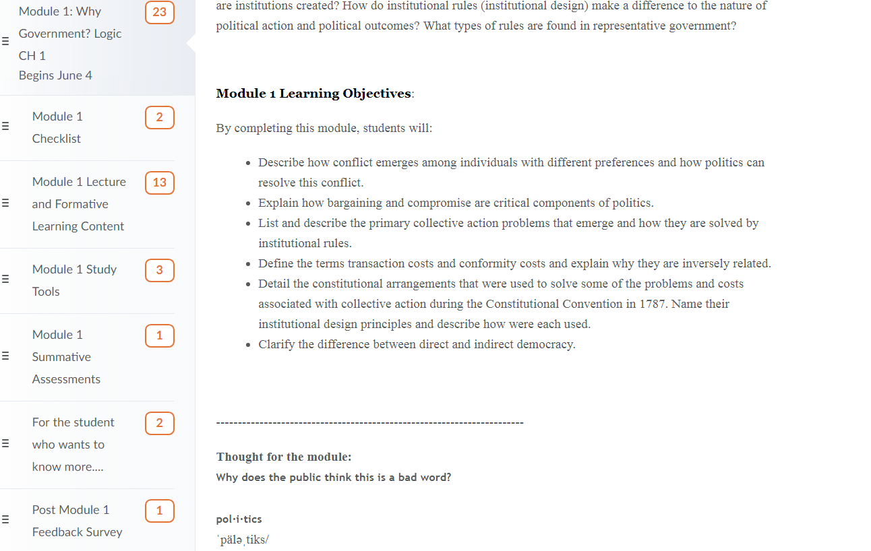

This is an example of what a Module Checklist will look like. Each checklist directions and links to the materials and assessments you will be working with.
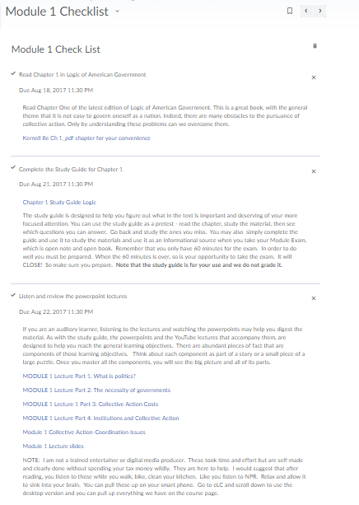
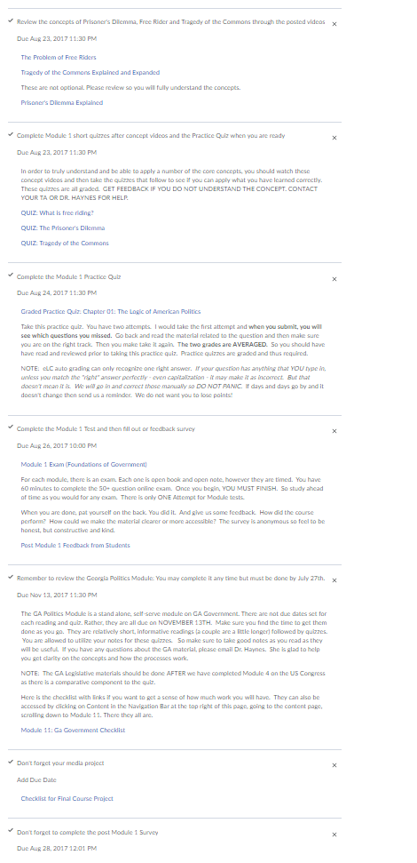
Policies: This course follows all policies related to Academic Honesty and Student Code of Conduct as outlined by the University of Georgia.

http://www.conduct.uga.edu/code_of_conduct/codeofconduct.pdf
http://ovpi.uga.edu/academic-honesty/academic-honesty-policy

Agreement: By enrolling in this course, you agree to adhere to these policies linked above and to do your best to be a good, productive, and honest student. You also agree to work with Dr. Haynes to make sure that you have a positive learning experience and a rewarding course outcome and that you will not neglect to stay on top of your work. Nor will you interact with your peers to collaborate on any exams, essays or projects unless they are clearly designated as group projects or work.

Given this is an online course that moves quickly, if you have any issues regarding test dates (such as a conflict, or you become ill during a portion of the course) it is imperative that you communicate with me (Dr. Haynes) and/or your assigned Teaching Assistant, and work out any issues. Your instructor (me) will try to be flexible given the online nature of this course, which may be new to some of you. So it is very important that you
keep communication lines open. It is very important that you stay on top of your reading and your test deadlines. I have designed this course so that while we move quickly, we are testing only one module at a time. Even though they are open book, given that they are time limited (and they will remain so – only those students with accommodations may seek extended time), you need to be prepared and knowledgeable or you will not be able to complete the test in the time allowed.

Dr. Haynes is an Aquarian. She loves sci fi books and movies. She thought End Game was disappointing. You will need to know this on the quiz.

